Program-1

package truthta;

/**

*

* @author ASHISH

*/

public class Truthta {

public static void main(String[] args) {

// TODO code application logic here

boolean x = false;

boolean y = false;

int j;

System.out.println("x\t y\t x&&y \t x||y \t !x \t !y");

for(int i = 1 ;i<=4;i++ ){

for (j = 1 ;j<2;j++ ){

System.out.print(x+"\t");

System.out.print(y+"\t");

}

if (j == 2)

System.out.println((x&&y)+"\t"+(x||y)+"\t"+(!x)+"\t"+(!y));

y = !y;

if ( i==2){

x=!x;

}

}

}

}

Output

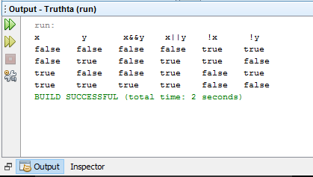

Program-1(b)

import java.util.Scanner;

/**

*

* @author ASHISH

*/

public class Switch {

public static void main(String[] args){

boolean x = false;

boolean y = false;

int j;

System.out.println("Enter the oprator to perform operation:--");

Scanner sc = new Scanner(System.in);

String s = sc.nextLine();

switch(s)

{

case "&" :

{

System.out.println("x\t y\t x&&y");

for(int i = 1 ;i<=4;i++ )

{

for (j = 1 ;j<2;j++ )

{

System.out.print(x+"\t");

System.out.print(y+"\t");

}

if (j == 2)

System.out.println(x&&y);

y = !y;

if ( i == 2)

x=!x;

}

}

break;

case "|" :

{

System.out.println( "x\t y\t x||y" );

for(int i = 1 ;i<=4;i++ )

{

for (j = 1 ;j<2;j++ )

{

System.out.print(x+"\t");

System.out.print(y+"\t");

}

if (j == 2)

System.out.println(x||y);

y = !y;

if ( i==2)

x=!x;

}

} break;

case "!" :

{

System.out.println("x\t y\t !x \t !y");

for(int i = 1 ;i<=4; i++ )

{

for (j = 1 ;j<2; j++ )

{

System.out.print(x+"\t");

System.out.print(y+"\t");

}

if (j == 2)

System.out.print(!x+"\t"+!y);

System.out.println(" ");

y = !y;

if ( i==2)

x=!x;

}

} break;

case "^" :

{

for(int i = 1 ;i<=4; i++ )

{

for (j = 1 ;j<2;j++ )

{

System.out.print(x+"\t");

System.out.print(y+"\t");

}

if (j == 2)

System.out.println(x^y);

y = !y;

if ( i==2 )

x=!x;

}

} break;

default:

System.out.println("Please Enter valid operator:--");

}

}

}

Output

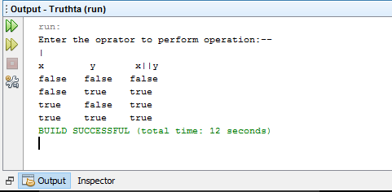

Program-2(a)

package pro2;

/**

*

* @author ASHISH

*/

public class Pro2 {

public static void main(String[] args) {

// TODO code application logic here

for(int i=0;i<=20;i++)

{

if (i % 2 != 0) {

System.out.println(i +" is a number odd " + " and square is = " + i * i);

}

}

}

}

Output

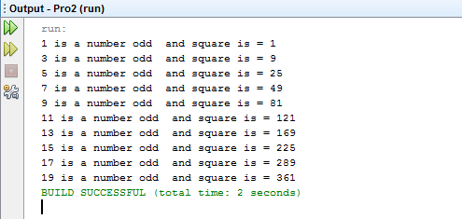

Program-2(b)

package pro2;

import java.util.Scanner;

public class Fibonacci {

public static void main(String[] args)

{

int i=1,n,t1=0,t2=1;

Scanner sc = new Scanner(System.in);

System.out.println("Enter the value of n");

n = sc.nextInt();

System.out.println("first "+n+" term");

while(i<=n)

{

System.out.print(t1 +" \t");

int sum=t1+t2;

t1=t2;

t2=sum;

i++;

}

}

}

Output

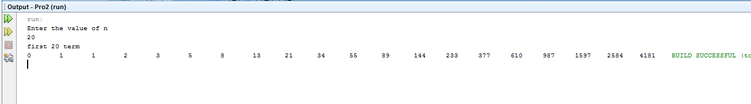

Program-3

Testcalculator.class

package calculator;\

import java.util.Scanner;

/**

* @author ASHISH

*/

public class Testcalculator {

public static void main(String[] args){

Scanner sc = new Scanner(System.in);

int n ;

float a,b,c;

do {

System.out.println("1: for Airthmatic Opration ");

System.out.println("2: for Logical Opration ");

System.out.println("3: for Relation Opration ");

System.out.println("4: for bitwise Opration ");

System.out.println("5: for exit ");

System.out.println("Enter your choice :--");

n = sc.nextInt();

Calculator cc = new Calculator();

//tc.cal(n);

switch(n)

{

case 1 : cc.Airthmatic();

break;

case 2 : cc.Logical();

break;

case 3 : cc.Relation();

break;

case 4 : cc.bitwise();

break;

case 5 : System.exit(0);

break;

default : System.out.print("Wrong Choice!!!");

break;

}

System.out.print("\n---------------------------------------\n");

}while (n!=5);

}

}

**Class calculator**

package calculator;

/**

*

* @author ASHISH

*/

import java.util.Scanner;

public class Calculator {

Scanner sc1 = new Scanner(System.in);

double a,b,c;

public void Airthmatic(){

System.out.println("Please Select Operation to Perform:");

System.out.println("1-Addition");

System.out.println("2-Subtraction");

System.out.println("3-Division");

System.out.println("4-Multiplication");

int n = sc1.nextInt();

switch(n)

{

case 1 : System.out.print("Enter Two Number : ");

a = sc1.nextFloat();

b = sc1.nextFloat();

c = a + b;

System.out.print("Result = " + c);

break;

case 2 : System.out.print("Enter Two Number : ");

a = sc1.nextFloat();

b = sc1.nextFloat();

c = a - b;

System.out.print("Result = " + c);

break;

case 3 : System.out.print("Enter Two Number : ");

a = sc1.nextFloat();

b = sc1.nextFloat();

c = a * b;

System.out.print("Result = " + c);

break;

case 4 : System.out.print("Enter Two Number : ");

a = sc1.nextFloat();

b = sc1.nextFloat();

c = a / b;

System.out.print("Result = " + c);

break;

case 5 : System.exit(0);

break;

default : System.out.print("Wrong Choice!!!");

break;

}

}public void Logical(){

boolean x = false;

boolean y = false;

int j;

System.out.println("x\t y\t x&&y \t x||y \t !x \t !y");

for(int i = 1 ;i<=4;i++ ){

for (j = 1 ;j<2;j++ ){

System.out.print(x+"\t");

System.out.print(y+"\t");

}

if (j == 2){

System.out.print((x&&y)+"\t"+(x||y)+"\t"+(!x)+"\t"+(!y));

}

System.out.print("\n");

y = !y;

if ( i==2){

x=!x;

}

}

}public void Relation(){

System.out.print("Enter Two Number : ");

a = sc1.nextFloat();

b = sc1.nextFloat();

System.out.print("Enter a operator : ");

String c= sc1.next();

switch(c){

case ">":

if (a > b)

System.out.println("a is greater than b");

else

System.out.println("a is less than or equal to b");

break;

case ">=":

if (a >= b)

System.out.println("a is greater than or equal to b");

else

System.out.println("a is lesser than b");

break;

case "<" :

if (a < b)

System.out.println("a is less than b");

else

System.out.println("a is greater than or equal to b");

break;

case "<=" :

if (a <= b)

System.out.println("a is lesser than or equal to b");

else

System.out.println("a is greater than b");

break;

case "==" :

if (a == b)

System.out.println("a is equal to b");

else

System.out.println("a and b are not equal");

break;

case "!=" :

if (a != b)

System.out.println("a is not equal to b");

else

System.out.println("a is equal b");

break;

default:

System.out.println("Please enter valid oprator ");

}

}public void bitwise()

{

System.out.print("Enter Two Number : ");

int x = sc1.nextInt();

int y = sc1.nextInt();

System.out.println("Please Select Operation to Perform:");

System.out.println("&");

System.out.println("!");

System.out.println(">>");

String n = sc1.next();

switch(n)

{

case "&" :

System.out.print("Result = " + (x&y));

break;

case "!" :

System.out.print("Result = " + ((x)|(y)));

break;

case ">>" :

System.out.print("Result = " + (x>>1));

break;

case " " : System.exit(0);

break;

default : System.out.print("Wrong Choice!!!");

break;

}

}

}

Output

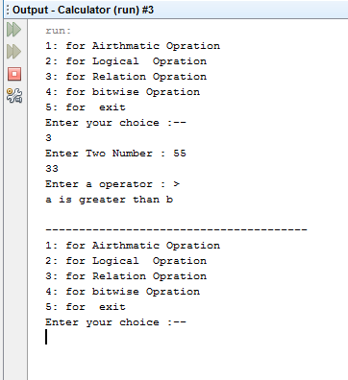

Program-4

package fruit;

/**

*

* @author ASHISH

*/

class Fruit {

private String seeds,category;

private int price;

Fruit(){

seeds = null;

category = null ;

price = 0;

}

Fruit(String x,String y, int z){

seeds = x;

category = y;

price = z;

}

void showOutput(){

System.out.println("Seeds = "+seeds);

System.out.println("category = "+category);

System.out.println("price = "+price);

}

public String getSeeds(){ return seeds; }

public String getCategory(){ return category; }

public int getPrice(){ return price; }

public String setSeeds(String x){

seeds = x;

return seeds;

}

public String setCategory(String x){

category = x;

return category; }

public int setPrice(int z){

price =z;

return price; }

}

public class Fruitt{

public static void main(String[] args) {

Fruit f = new Fruit();

System.out.println("Seed "+f.getSeeds());

System.out.println("category"+f.getCategory());

System.out.println("price "+f.getPrice());

System.out.println("----------------------------------");

Fruit f1 = new Fruit("a","z",1);

f1.setSeeds("ccc");

f1.showOutput();

}

}

Output

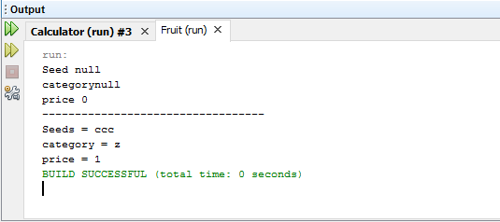

Program-5

Employee.class

public class Employee {  
 private String name;  
 private String gender;  
 private String officeName;  
 Employee(){ super();name= "ashish"; gender = ""; }  
 Employee(String officeName){ this.officeName = officeName ;}  
 public String getName() {  
 return name;  
 }  
  
 public String getGender() {  
 return gender;  
 }  
  
 public String getOfficeName() {  
 return officeName;  
 }  
  
 public void setName(String nam) {  
 this.name = nam;  
 }  
  
 public void setGender(String gender) {  
 this.gender = gender;  
 }  
 void showOutput(){  
 System.*out*.println("GeNder of employee "+gender);  
 System.*out*.println("Name of employee "+name);  
 System.*out*.println("**************************************");  
 }  
}

Worker. class

public class Worker extends Employee  
{  
 private char category;  
 private boolean dressallowence;  
 Worker(){  
 category ='c';  
 dressallowence = true;  
 }  
  
 public char getCategory() {  
 return category;  
 }  
  
 public void setDressallowence(boolean dressallowence) {  
 this.dressallowence = dressallowence;  
 }  
  
 public void setCategory(char category) {  
 this.category = category;  
 }  
 public boolean getDressallowence(){  
 return dressallowence;  
 }  
 void showOutput(){  
 System.*out*.println("Category of Worker "+category);  
 System.*out*.println("Name of emp :-"+getName());  
 setGender("mail");  
 System.*out*.println("Gender of employee :-"+getGender());  
 System.*out*.println("dreassAllowece of Worker"+dressallowence);  
 System.*out*.println("**************************************");  
  
 }  
  
}

Office.class

public class Officer extends Employee  
{  
 private char category;  
 private int experience;  
 private boolean vehicle;  
 Officer(){  
  
 category = 'a';  
 experience = 0;  
 vehicle = false;  
 }  
 Officer(String officeName){  
  
 super(officeName);  
 }  
  
 public char getCategory() {  
 return category;  
 }  
  
 public int getExperience() {  
 return experience;  
 }  
 public boolean getVehicle() {  
 return vehicle;  
 }  
  
 public void setCategory(char category) {  
 this.category = category;  
 }  
  
 public void setExperience(int experience) {  
 this.experience = experience;  
 }  
  
 public void setVehicle(boolean vehicle) {  
 this.vehicle = vehicle;  
 }  
 void showOutput(){  
 System.*out*.println("Category of Officer:-"+category);  
 System.*out*.println("Experiece of Officer:-"+experience);  
 System.*out*.println("Vehical of Officer:-"+vehicle);  
 System.*out*.println("Name of office :-"+getOfficeName());  
 System.*out*.println("**************************************");  
 }  
}

Super.class

public class Super {  
 public static void main(String[] args) {  
 Worker w = new Worker();  
 Officer o = new Officer();  
 Officer o1 = new Officer("Super office ");  
 System.*out*.println("**************************************");  
  
 o.setCategory('g');  
 o.setExperience(3);  
 o.setVehicle(true);  
 o.showOutput();  
 System.*out*.println("Worker catrgory "+w.getCategory());  
 System.*out*.println("Worker Dress "+w.getDressallowence());  
 System.*out*.println("**************************************");  
 w.showOutput();  
  
 }  
}

Output

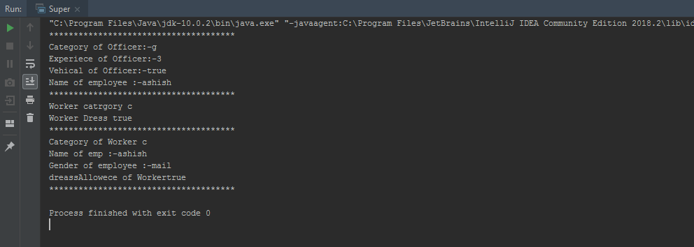

Program-5

Card.class

public class Card  
{  
 //public static int king;  
 private final int rank; // Shapes of cards  
 private final int suit; // Values of cards  
 //-------------Define suit value---------------------------------------//  
 private static int *Spade* = 1;  
 private static int *Heart* = 2;  
 private static int *Diamond* = 3;  
 private static int *Club* = 4;  
 //-------------Define rank---------------------------------------//  
 private static int *Ace* = 1 ;  
 private static int *Two* = 2 ;  
 private static int *Three* = 3 ;  
 private static int *Four* = 4 ;  
 private static int *Five* = 5 ;  
 private static int *Six* = 6 ;  
 private static int *Seven* = 7 ;  
 private static int *Eight* = 8 ;  
 private static int *Nine* = 9 ;  
 private static int *Ten* = 10 ;  
 private static int *Jack* = 11 ;  
 private static int *Queen* = 12 ;  
 private static int *King* = 13 ;  
 //------------------Constructor----------------------------------//  
 // Card(){ suit = 0; rank = 0; } //Default  
 public Card(int suit,int rank)  
 {  
 // = (int)(Math.random()*(suit));  
 // = (int)(Math.random()*(rank));  
 this.rank = rank;  
 this.suit = suit;  
 }  
 //----------------------------------------------------//  
 public int getSuit() { return suit; }  
  
 public int getRank() { return rank; }  
  
 public static int getAce() {  
 return *Ace*;  
 }  
  
 public static int getHeart() {  
 return *Heart*;  
 }  
  
 public static int getSpade() {  
 return *Spade*;  
 }  
  
 public static int getClub() {  
 return *Club*;  
 }  
  
 public static int getDiamond() {  
 return *Diamond*;  
 }  
  
 public static int getEight() {  
 return *Eight*;  
 }  
  
 public static int getFive() {  
 return *Five*;  
 }  
  
 public static int getFour() {  
 return *Four*;  
 }  
  
 public static int getJack() {  
 return *Jack*;  
 }  
  
 public static int getKing() {  
 return *King*;  
 }  
  
 public static int getNine() {  
 return *Nine*;  
 }  
  
 public static int getQueen() {  
 return *Queen*;  
 }  
  
 public static int getSeven() {  
 return *Seven*;  
 }  
  
 public static int getSix() {  
 return *Six*;  
 }  
  
 public static int getTen() {  
 return *Ten*;  
 }  
  
 public static int getThree() {  
 return *Three*;  
 }  
  
 public static int getTwo() {  
 return *Two*;  
 }  
  
 //-------------------int-To-String---------------------------------//  
 String suit_toString(int s)  
 {  
 switch (s)  
 {  
 case 1: return "Spade";  
 case 2: return "Heart";  
 case 3: return "Diamond";  
 case 4: return "Club";  
 }  
 return null;  
 }  
 String rank_toString(int r)  
 {  
 switch (r)  
 {  
 case 1: return "Ace";  
 case 2: return "Two";  
 case 3: return "Three";  
 case 4: return "Four";  
 case 5: return "Five";  
 case 6: return "Six";  
 case 7: return "Seven";  
 case 8: return "Eight";  
 case 9: return "Nine";  
 case 10: return "Ten";  
 case 11: return "Jack";  
 case 12: return "Queen";  
 case 13: return "King";  
 }  
 return null;  
 }  
}

Deck.class

public class Deck  
{  
 private static int *numSuit* = 4;  
 private static int *numRank* = 13;  
 public static int *numCards* = *numRank* * *numSuit*;  
  
 Card [][] Cards ;  
  
 Deck()  
 {  
 Cards = new Card[*numSuit*][*numRank*];  
 for (int suit = Card.*getSpade*(); suit <= Card.*getClub*(); suit++)  
 for (int rank = Card.*getAce*(); rank <= Card.*getKing*(); rank++)  
 Cards[suit-1][rank-1] = new Card(suit, rank);  
 }  
  
 public Card[][] getCards() {  
 return Cards;  
 }  
  
 public Card get_Card(int suit, int rank)  
 {  
 return (Cards[suit][rank]);  
 }  
  
 void shuffle(int repeat)  
 {  
 int suit , rank ;  
 Card c ;  
 while (repeat >0)  
 {  
 for (int i = *numSuit* - 1;i>0;i--)  
 {  
 for (int j = *numRank* - 1; j > 0; j--)  
 {  
 suit = (int)(Math.*random*()*(i+1));  
 rank = (int)(Math.*random*()*(j+1));  
 c = Cards[i][j];  
 Cards[i][j] = Cards[suit][rank];  
 Cards[suit][rank] = c;  
  
 }  
  
 }  
  
 repeat--;  
 }  
 }  
 boolean compare(char a,Card c1,Card c2)  
 {  
 int suit1 = c1.getSuit();  
 int suit2 = c2.getSuit();  
 int rank1 = c1.getRank();  
 int rank2 = c2.getRank();  
  
 if(a=='l')  
 {  
 if (suit1 > suit2)  
 return true;  
 else if (suit2 == suit1)  
 {  
 if (rank1>rank2)  
 return true;  
 return false;  
 }  
 }  
 else if (a=='h') {  
 if (suit1 < suit2)  
 return true;  
  
  
 else if (suit1 == suit2) {  
 if (rank1 < rank2)  
 return true;  
 return false;  
 }  
 }  
 return false;  
 }  
}

play.class

import java.util.Scanner;  
  
public class play {  
 public static void main(String[] args)  
 {  
 Deck d = new Deck();  
 // Card c = new Card(4,10);  
 char a = 'y';  
 Scanner sc = new Scanner(System.*in*);  
 Card c1 = d.get_Card(1,1);  
 while (a == 'y') {  
 d.shuffle(3);  
 Card c2 = d.get_Card(1, 1);  
 System.*out*.println("Comparing Card is: "+c1.suit_toString(c1.getSuit()) + " of " + c1.rank_toString(c1.getRank()));  
 System.*out*.println("Enter h for next card to b higher and l for next card to be lower the value of above shown card: ");  
 char n = sc.next().charAt(0);  
 boolean b = d.compare(n, c1, c2);  
 if (b)  
 System.*out*.println("You Win");  
 else  
 System.*out*.println("You loose");  
 System.*out*.println("Next Card is: "+c1.suit_toString(c2.getSuit()) + " of " + c1.rank_toString(c2.getRank()));  
 System.*out*.println("If you wanna continue press y else press n: ");  
 a = sc.next().charAt(0);  
 if (a == 'y')  
 c1 = c2;  
 }  
  
 }  
}

Output

